**CENWP-OD-B 24 July 2024**

**MEMORANDUM FOR THE RECORD**

**SUBJECT: 24BON034 MFR AFF Trap Walkway Pacific Lamprey Mortality**

On Wednesday morning 24 July 2024, CRITFC staff found one Pacific Lamprey mortality on the walkway near the AFF lamprey trap. The cause of the fish being on the walkway in unknown and could include bird predation or flipping off the AFF trap flume section. A photo of the mortality was taken at the time of removal from the trap area and is attached. The individual was scanned for PIT tags and frozen for potential future pathogen evaluation.

1. Species – Pacific Lamprey (*Entosphenus tridentatus*)
2. Origin – unknown
3. Length – 63 cm
4. Marks and tags – none
5. Marks and Injuries found on carcass – none
6. Cause and Time of Death – unknown
7. Future and Preventative Measures – Repair/replace netting on upper flume section.

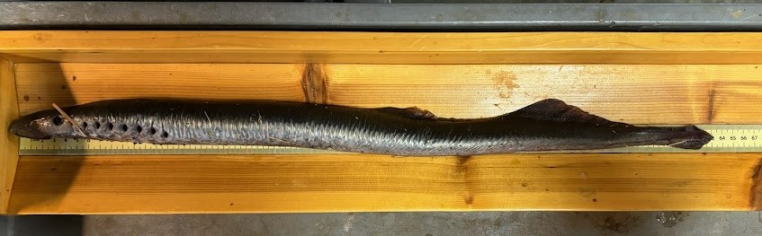

Sincerely,

Bonneville Project Fisheries